McWilliam News Report 1 - Photo Gallery

Photo #1: Alumni player carries the puck over the blue line

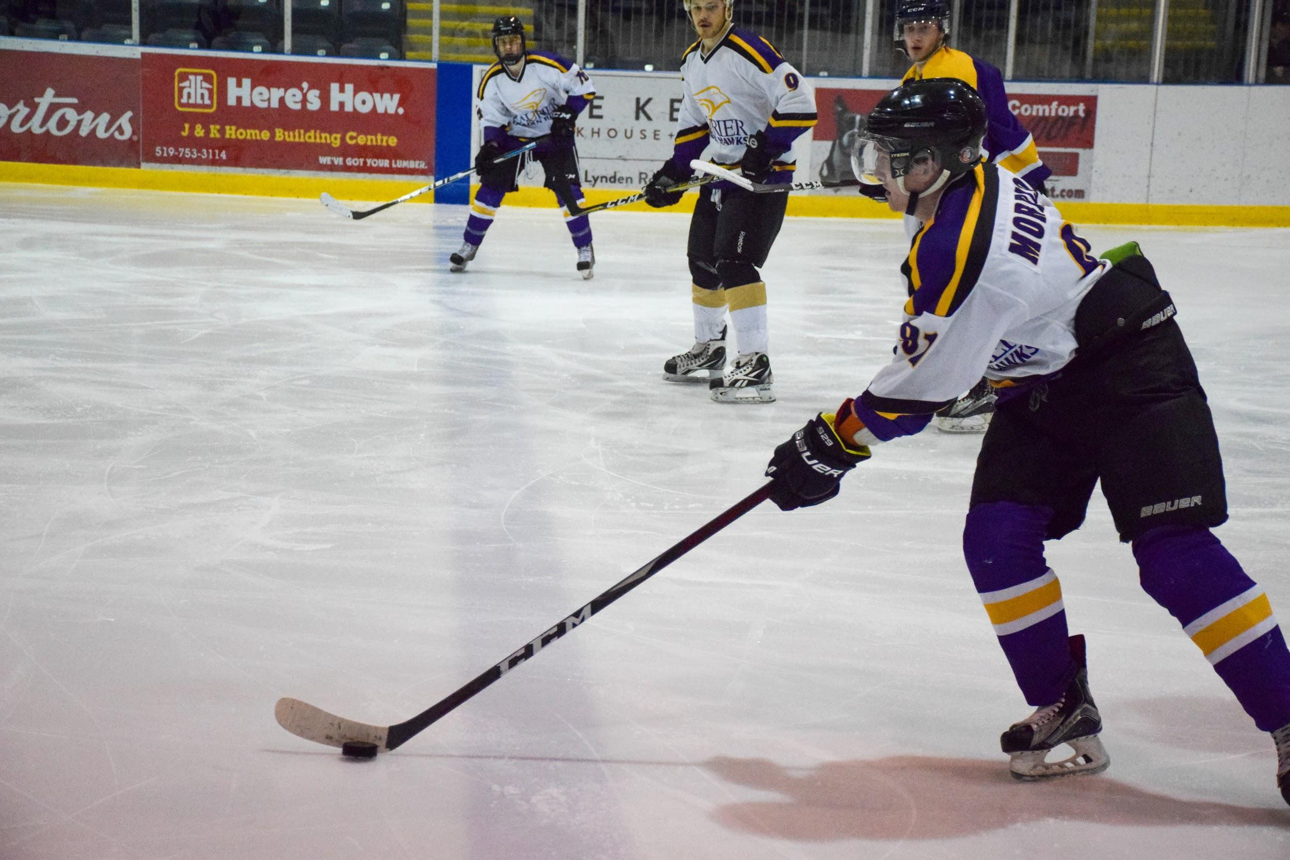

Photo #2: Heated game leads to pushing and shoving after whistle

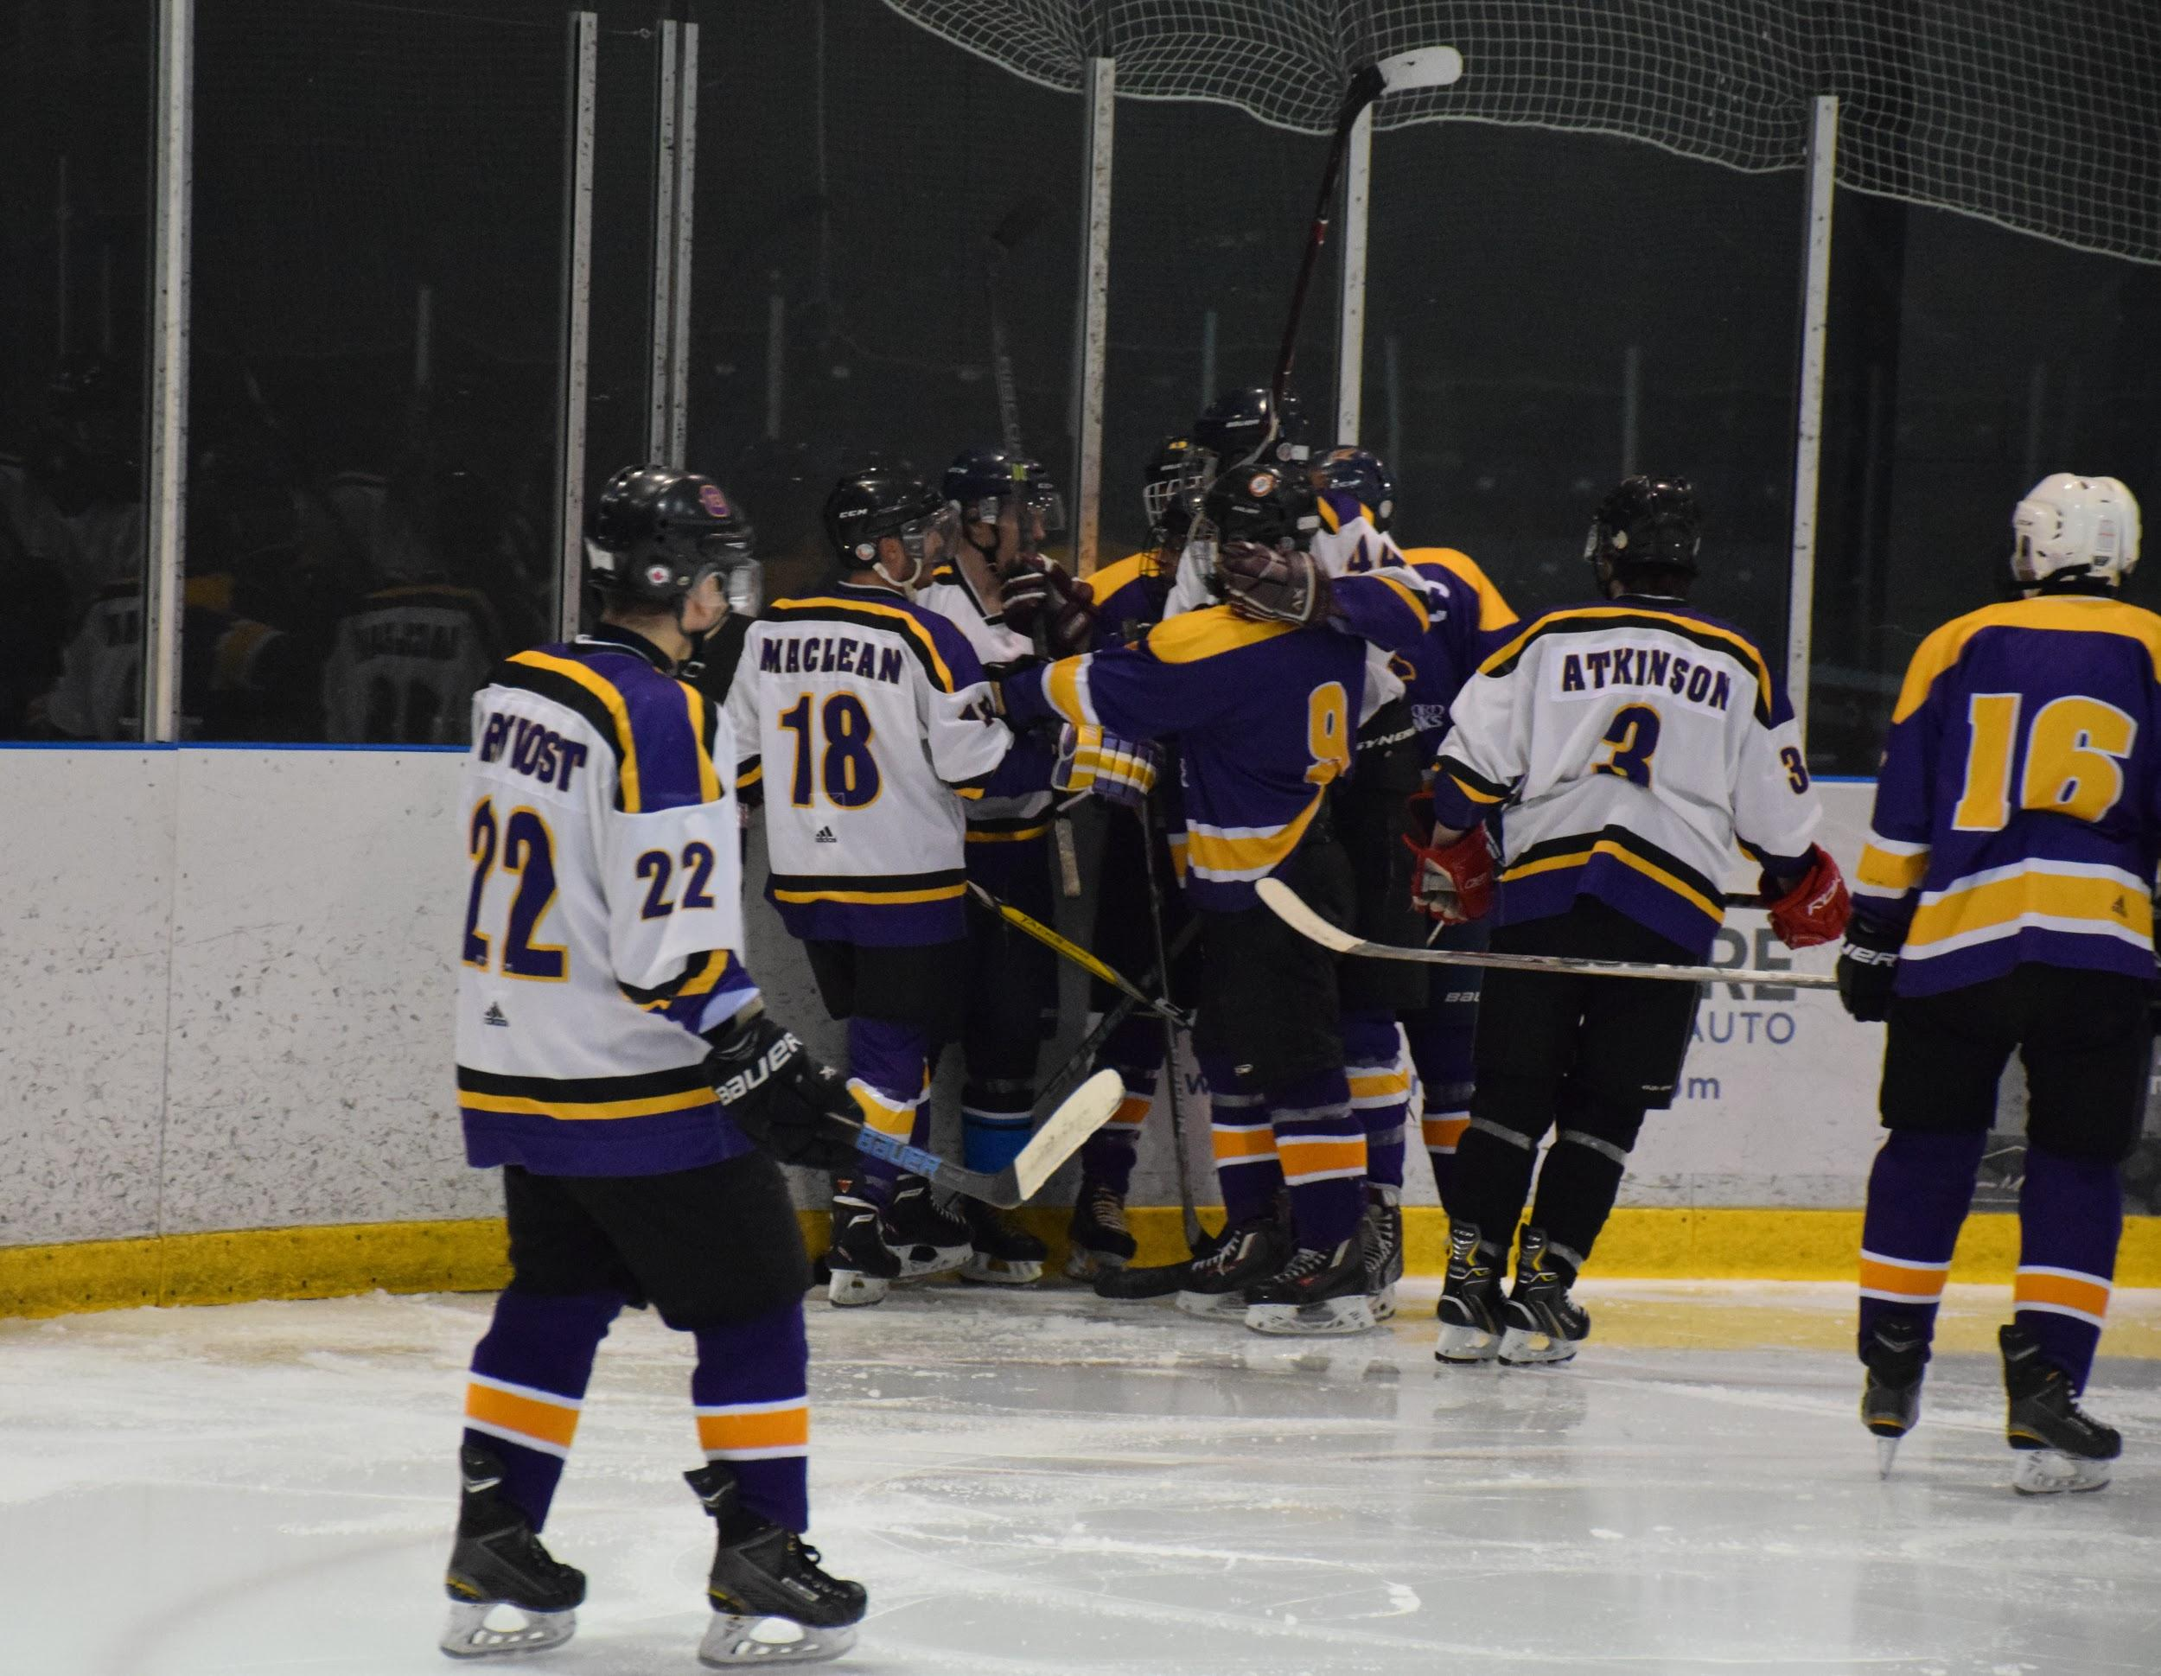

Photo #3: Laurier player skates to bench after a long shift

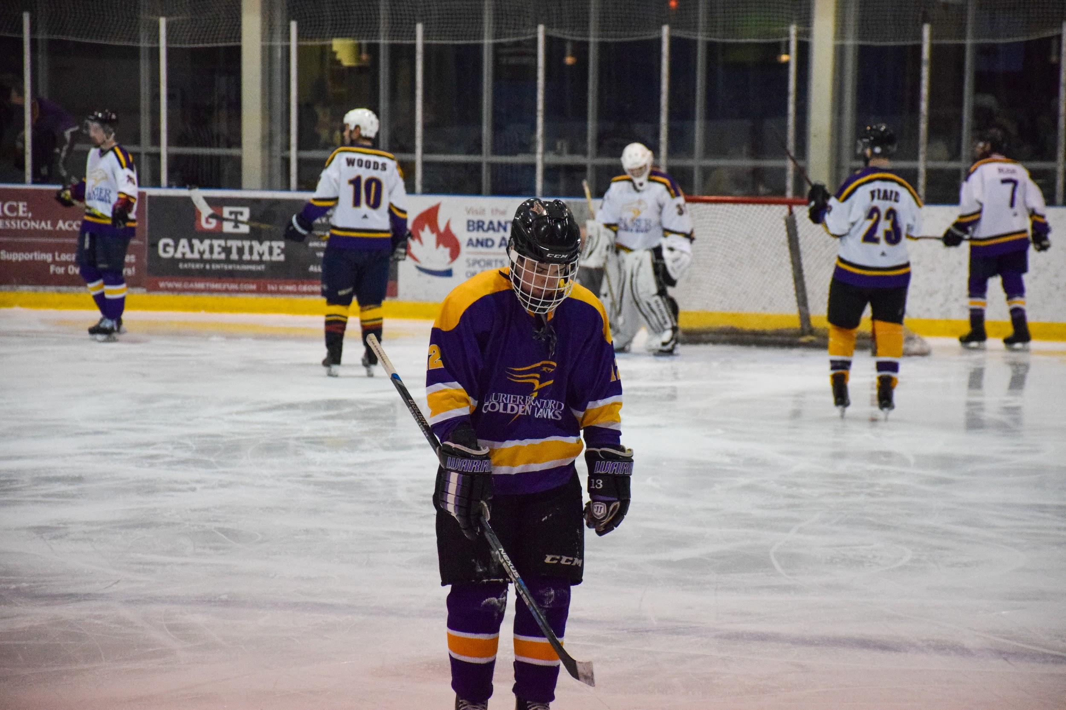

Photo #4: Alumni wraps around the net with Laurier giving chase

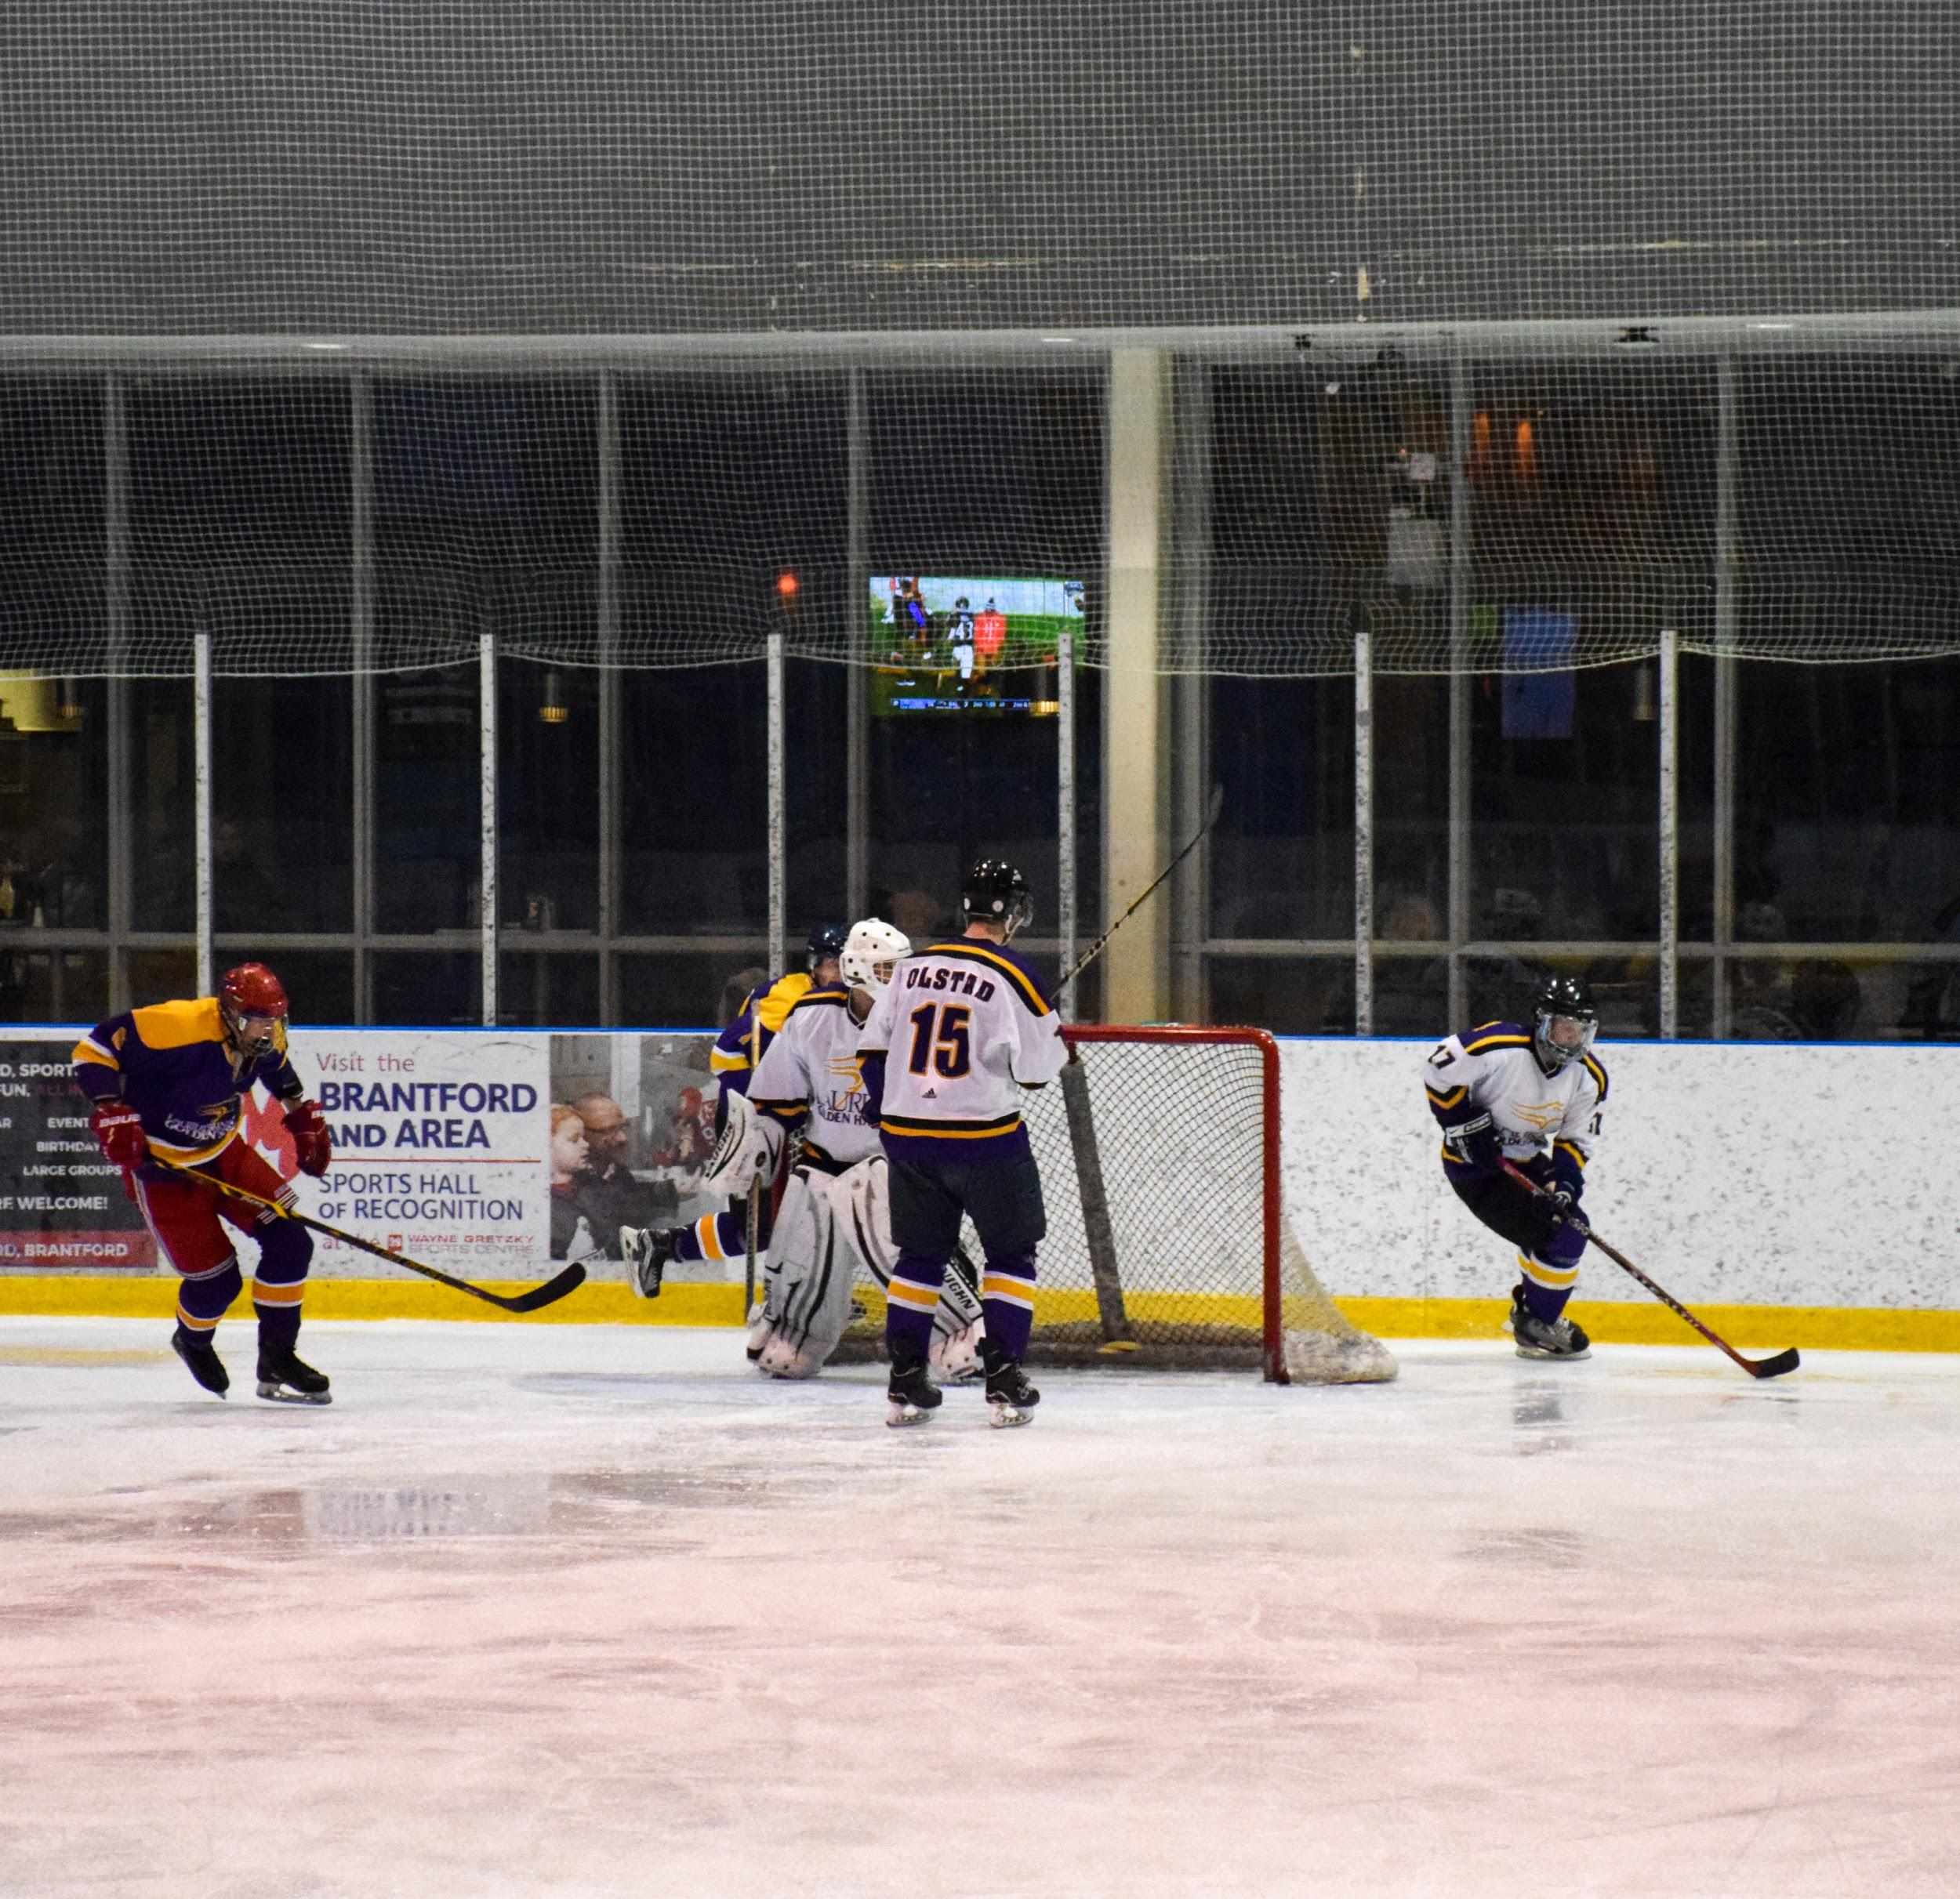

Photo #5: Alumni player looks for an open pass while crossing centre ice

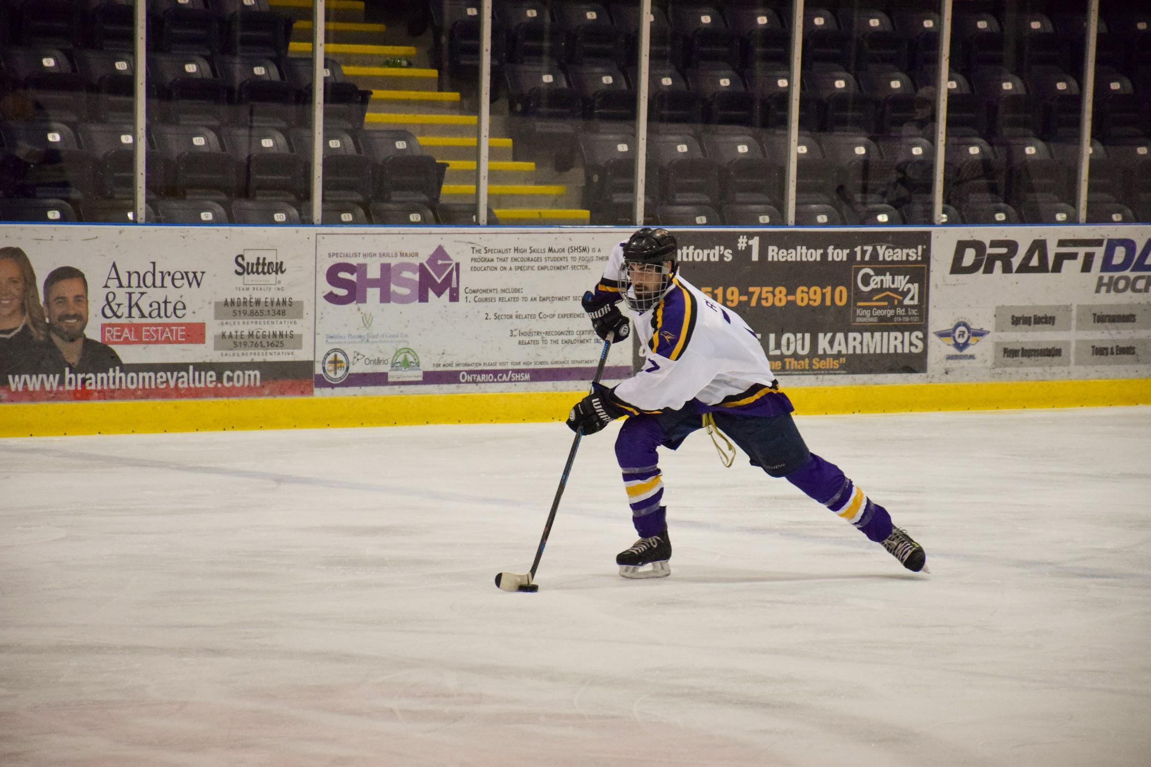

Photo #6: Laurier sneaks behind Alumni to snatch the puck

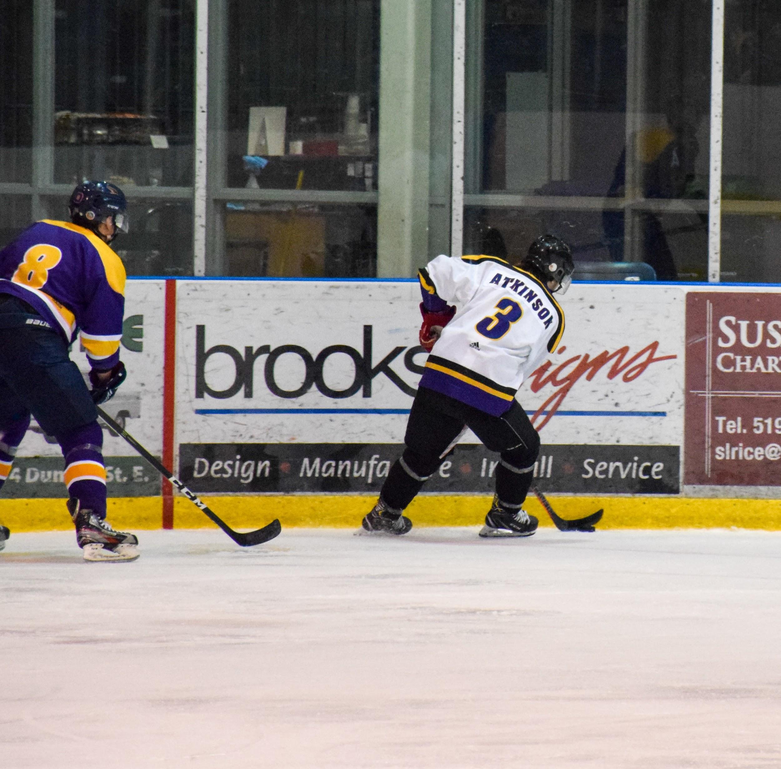

Photo #7: Both teams line up for a group photo after game

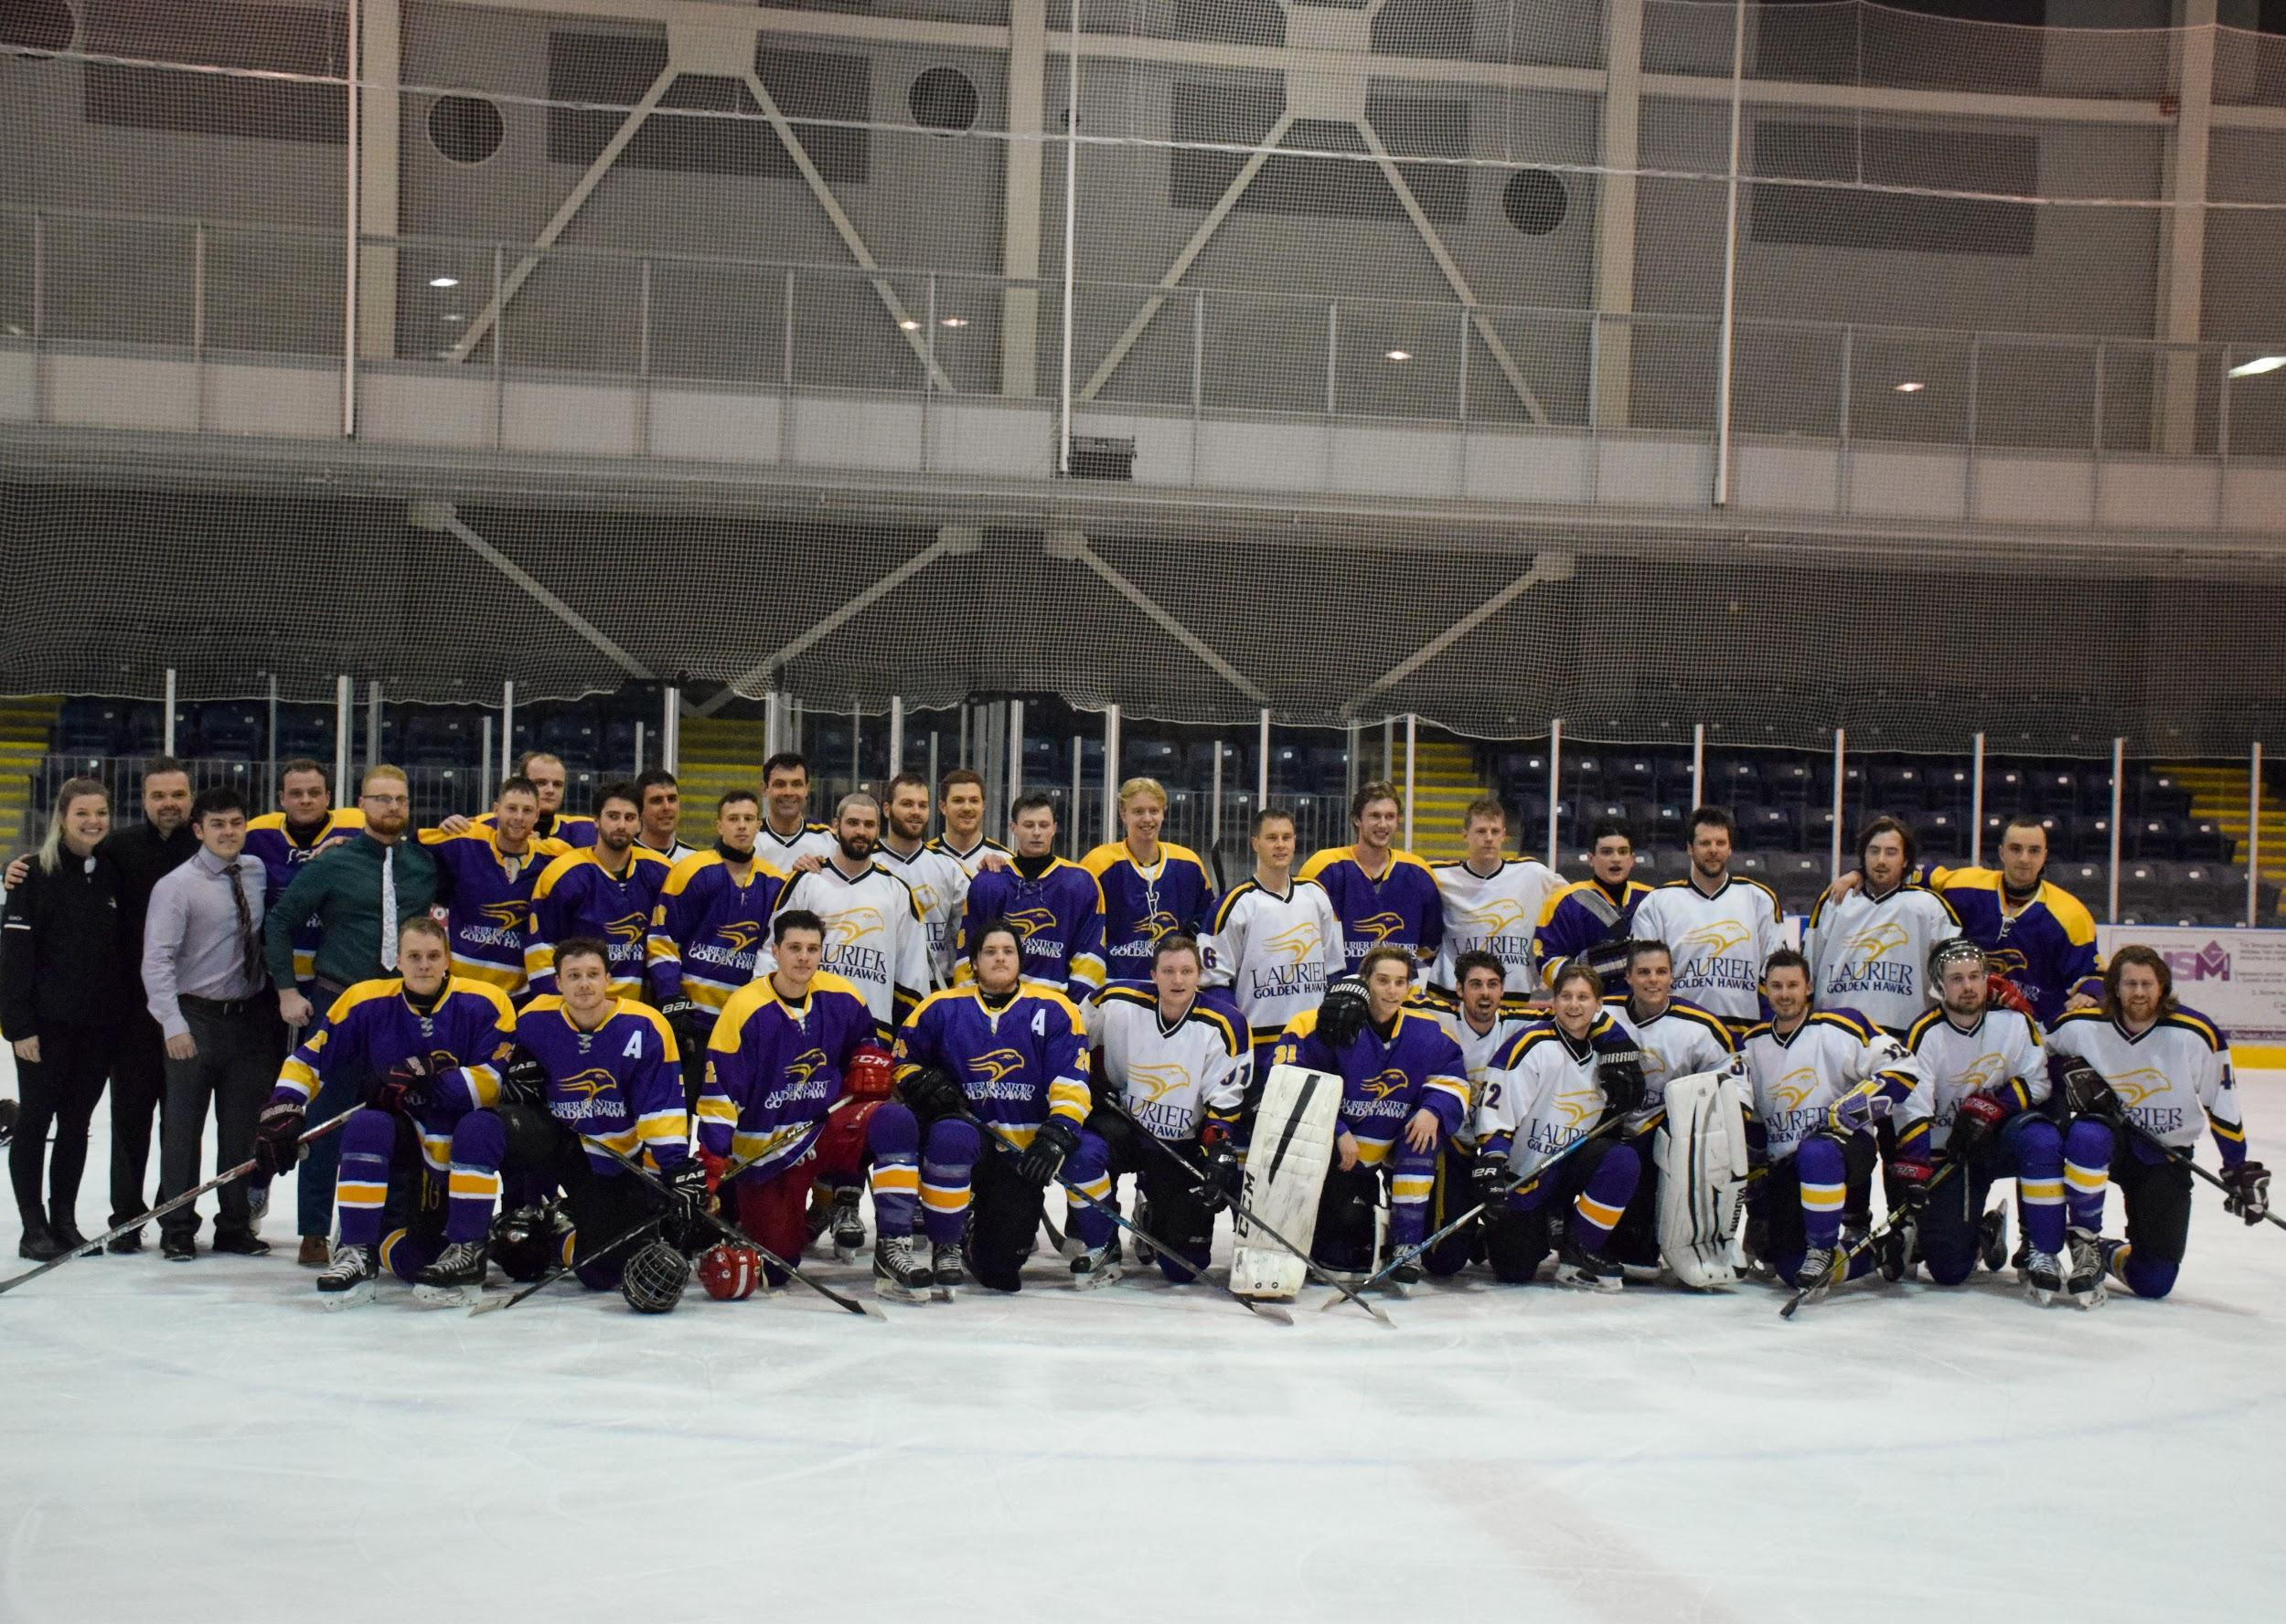

Photo #8: Alumni team after their win

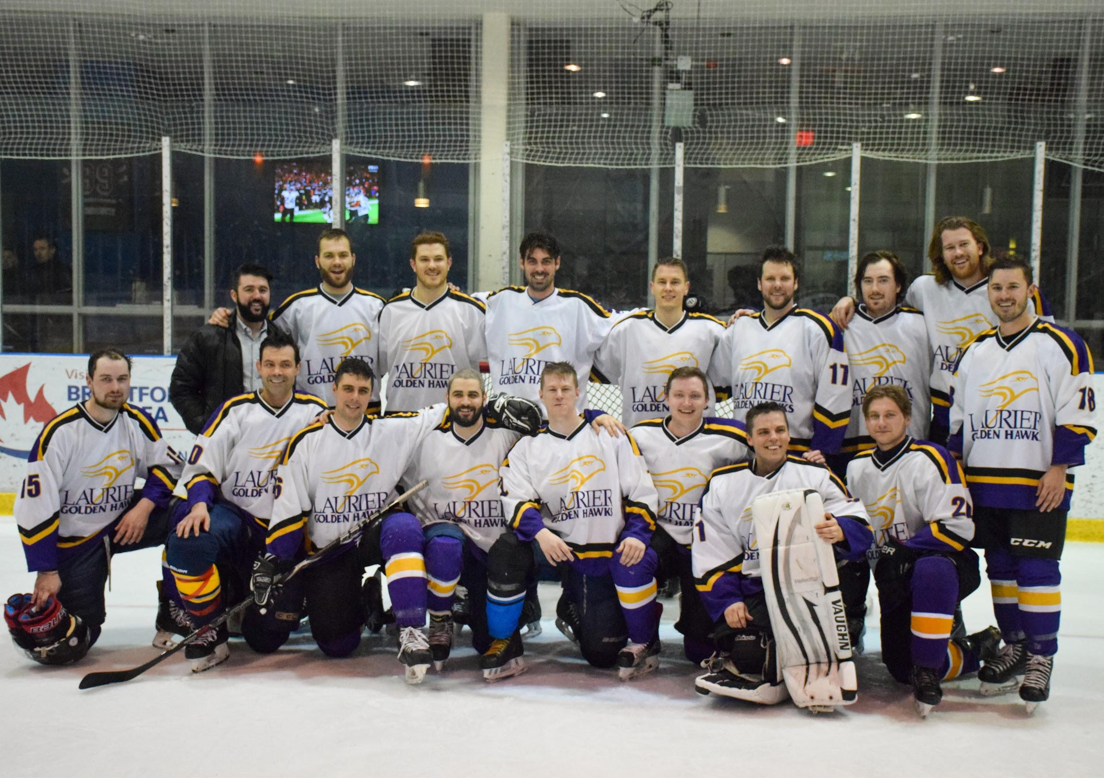

Photo #9: Laurier team leaders hold their head up after tough loss

